Money Module
Mike’s bank account looks good but at a glance, he can’t easily see which transactions are related to his snack bar or his catering business.
He finds that at the end of the week, he’s using excel to record details from his bank account and credit card to figure it out. Mike would like to record a description of the transaction indicating whether or not the transaction was income or expense and more details of what the transaction was for.
Mike usually pays for supplies using his credit card. Mike’s clients pay by cash, credit or debit.
Mike must remit HST quarterly to the Canada Revenue Agency. For this reason, Mike would like to know how much he’s paid and collected in HST.
He’d like a more robust system than Excel to manage these details.
Your task is to read the User Story below and create a class diagram and sequence diagrams to support the scenario.

User Story
As the owner of this business, I would like to record my financial transactions so that I can quickly see how much money I’ve made and what I owe the government in HST. For my purposes, my expenses subtracted from my income.

Acceptance Criteria:
- Must be able to query transactions by date and provide a total profit and total HST
- Must be able to query transactions by date and by source of the income.
- Differentiate between expenses and income – provide a running total of income – expenses
- Calculate the HST owed to the government by subtracting HST paid on expenses from HST collected on income.

Use Case Descriptions

Use Case Name | Create an income transaction
Triggering Event | Money coming into the business.
Brief Description | Allows the Owner to record an income transaction.
Actors | Owner
Related Use Cases
Preconditions | Owner has opened the Main Menu.
Post Conditions | Income transaction is saved and added to financial totals.
Flow of activities | Actor |  | System
 |  | Requests to add a new income transaction | Displays a calendar  Prompts for description, transaction amount and HST amount  Displays a list of income sources and prompts for selection
 |  | Selects the transaction Date  Selects the income source  Enters the transaction description  Enters the transaction amount | Verifies that date is selected  Verifies that description and amount have been entered  Verifies that the income source was selected.  Calculates HST  Displays financial transaction  Prompts to save
 |  | Request to save | Saves the transaction and returns to the main menu
Exception Conditions | - Owner chooses to cancel adding the transaction

Use Case Name | Create an expense transaction
Triggering Event | Money leaving the business.
Brief Description | Allows the Owner to record an expense transaction.
Actors | Owner
Related Use Cases
Preconditions | Owner has opened the Main Menu.
Post Conditions | Expense transaction is saved and added to financial totals.
Flow of activities | Actor |  | System
 |  | Requests to add a new expense transaction | Displays a calendar  Prompts for description, transaction amount and HST amount
 |  | Selects the transaction Date  Enters the transaction description  Enters the transaction amount | Verifies that date is selected  Verifies that description and amount have been entered  Calculates HST  Displays financial transaction  Prompts to save
 |  | Request to save | Saves the transaction and returns to the main menu
Exception Conditions | - Owner chooses to cancel adding the transaction

Use Case Name | Query Financial Transaction (Income and Expenses)
Triggering Event | Owner requires a list of transactions for a date period including Total Income, Total Expenses, Total Profit, Total HST collected, Total HST Paid, HST Owed
Brief Description | Allows the Owner to retrieve financial totals for a specified date range
Actors | Owner
Related Use Cases
Preconditions | Owner has opened the Main Menu.
Post Conditions | Financial transactions are retrieved, totaled and displayed
Flow of activities | Actor |  | System
 | 1. | Requests to query financial transactions | Displays a calendar
 | 2. | Selects date range | Verifies that dates are selected  Retrieves transactions in the specified date range  Calculates and displays total income, total expenses, Profit, total HST Owed. Prompts to exit
 | 3. | Request to exit | returns to the main menu
Exception Conditions

Your tasks:
- Create a class diagram to support the above case study and Systems Use Case Specifications
- Create an object level sequence diagram, detailing the Create Income Transaction systems use case specification
- Create an object level sequence diagram, detailing the Create Income Transaction systems use case specification
- Create an object level sequence diagram, detailing the Query Financial Transaction system use case specification.

USE CASE DIAGRAM
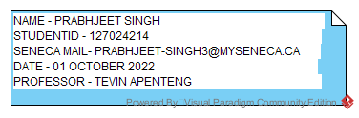
CLASS DIAGRAMS

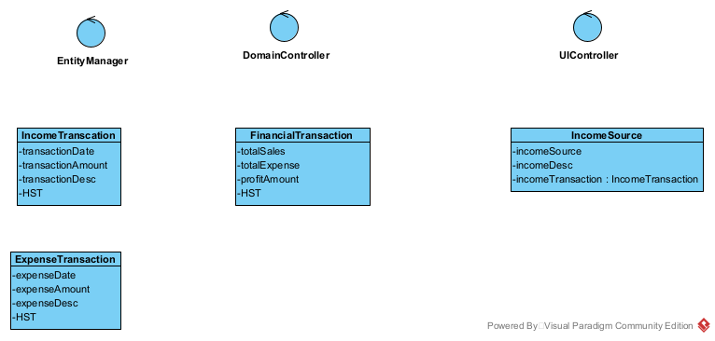

SEQUENCE DIAGRAMS

Create an income transaction 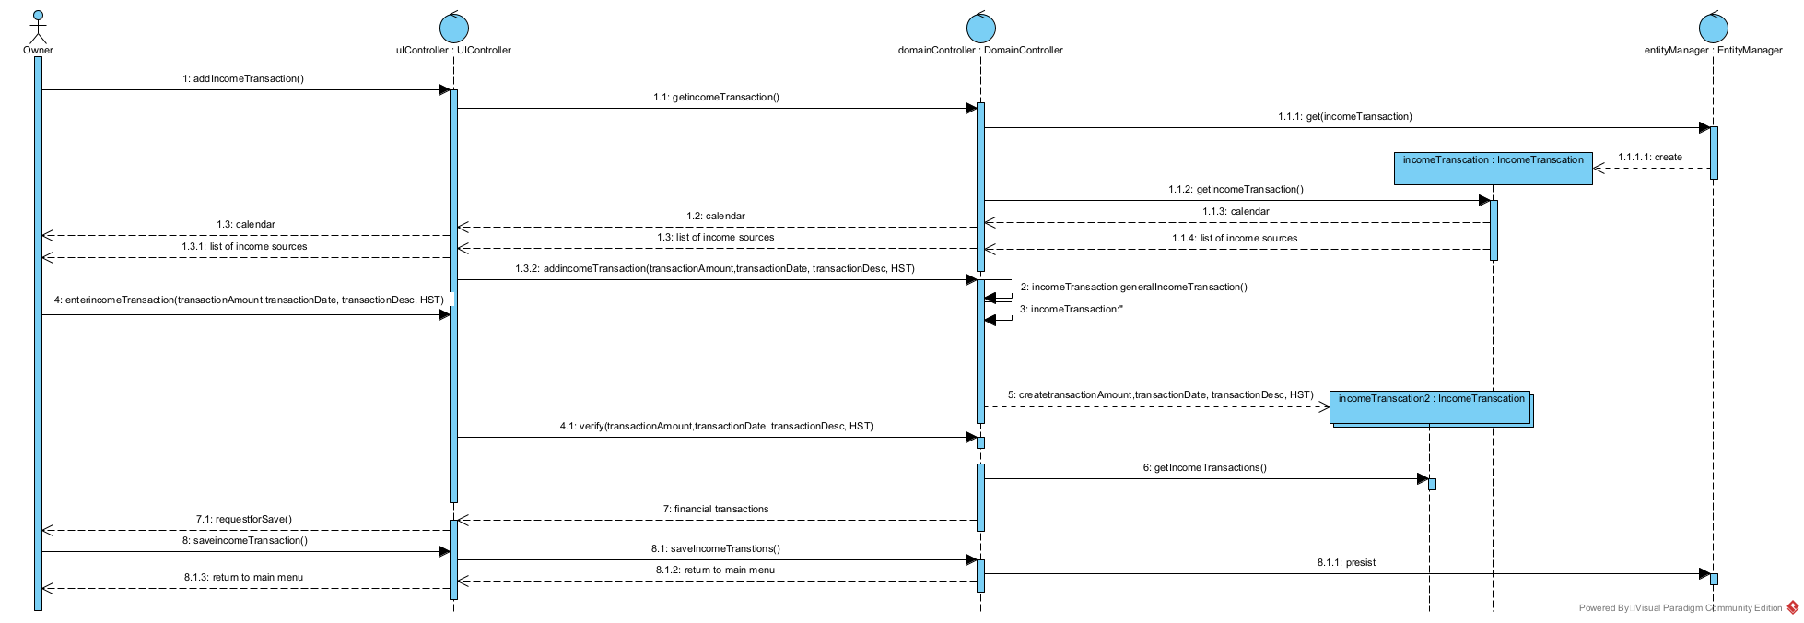
Query Financial Transaction (Income and Expenses)
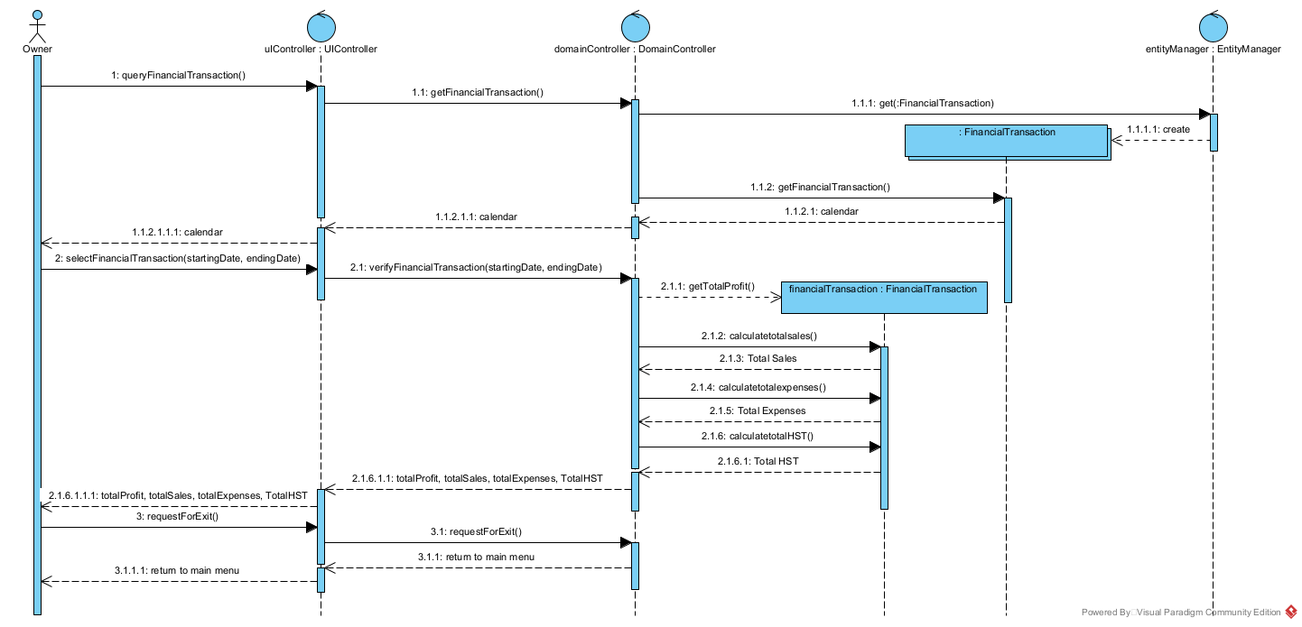

Create an expense transaction
